Trading on behalf (members procedure)

Summary

Objective of the procedure | Describe actions to be taken by MEMO member to submit orders in case of Trading on Behalf is needed.
Concerned persons | MEMO members on day-ahead markets

Historical of the document (Update must be performed after any modification of the process)

Historical of modifications
Evolution | Date | Version | Comments
Creation | 10/05/2023 | 1.0 | Initial version

Current version must be designated with grey background

SUMMARY
1. Introduction 3
2. Business process 3
2.1 Download the excel forms from our website 3
2.2 Filling of the excel form 3
2.3 Check the file 5
2.4 Put your orders 5
2.5 Send your file via email and call Market Operations 5

Introduction

Dear member,

The Trade on Behalf (ToB) process aims to be a supporting tool when isolated issues occur disrupting your connection with the ETS system. In this case, you can download the excel forms from our website for the respective auction from this link The procedure giving all details and steps to follow must be found by using the below link

The ToB process is meant to be operated on a best effort basis, this is why you must call our Market Operations department as of when you have emailed the forms and also to try to send the form(s) as soon as possible in order to ensure they will be processed correctly (avoid waiting until close to the OBK time).

Business process

Below you will find the instructions on how to fill in the form and how to send it to Marker Operations Team for validation.

The form has to be sent 15 min before the gate closure time at the latest.
The form needs to be sent by e-mail.

Download the excel forms from our website

Select the correct form based on the type of order (linear / block) and 25Hours for Long Day DST or the ones for normal day.
- The ones for the normal day should be used for Short Day DST without filing in the impacted periods.

Filling of the excel form

Fill in the trader name (only authorized traders are allowed to send a ToB form and request its submission) and the respective portfolio as well as the type of the order (new, modification of existing one or cancellation of an existing one).

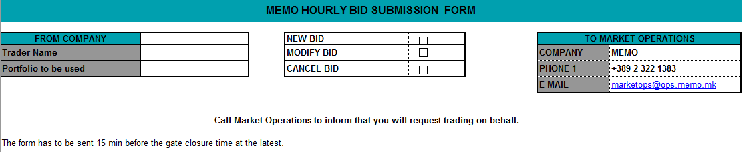

Check the file

Ensure that the auction (and area), the trading and delivery days are correct

Put your orders

Please add the prices and volumes carefully.

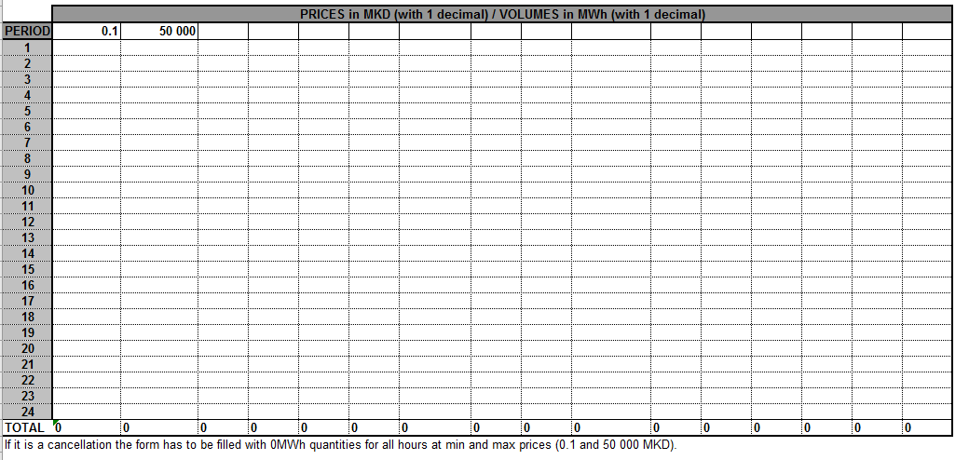

Send your file via email and call Market Operations

Send the file(s) via email to market operations team and also call the team to ensure the process is still available and it has been correctly submitted.

Please send the forms via email to: marketops@ops.memo.mk

and then call: +389 2 322 1383

Market Operators will inform the trader the bid has been entered successfully into the Trading System.

Market Operators will send to the trader an export or a screenshot of his order.

